**Zapier**

**Title: Integrating Agentic AI with Zapier: Simplifying Access to Tools**

**Explanation:**

To make our Agentic AI or custom GPT truly powerful, we need to connect it to real-world tools like Google Docs, Office 365, Salesforce, and more. Doing this directly with each tool would be incredibly complex, as there are thousands of different systems and interfaces to manage. Instead, we use a platform called Zapier to simplify this process.

**What is Zapier?**

Zapier is a platform that allows you to build automations, called "Zaps," that can connect different systems and perform tasks automatically. Traditionally, these automations had to be set up by humans. However, by integrating Zapier with our GPT, the AI can now trigger these automations on its own, handling complex tasks across multiple systems with ease.

**Example 1: Simplifying Integration Across Multiple Systems**

* **Scenario**: Imagine trying to teach a GPT to interact with different tools like Google Suite, Office 365, and Salesforce. Each tool has its own unique interface, making direct integration with GPT overwhelming.
* **Solution**: By connecting GPT to Zapier, you provide the AI with a single, simplified interface that can interact with all these tools through Zapier's pre-built automations. This means GPT can perform tasks across various systems without needing to understand the complex details of each one.

**Example 2: Automating Routine Tasks**

* **Scenario**: Suppose you want your GPT to update your personal calendar, send emails, or manage files in Dropbox. Doing this manually or teaching GPT each individual interface would be tedious.
* **Solution**: With Zapier, you can create Zaps that automate these tasks. The GPT can now trigger these automations, handling tasks like updating calendars or managing files automatically, all through a single interface.

**Getting Started:**

To integrate GPT with Zapier, you'll need to sign up for a Zapier account. The platform offers a 14-day free trial, allowing you to explore its capabilities. Once connected, you can start creating powerful automations that your GPT can control, making your AI more versatile and effective in managing everyday tasks.

**Title: Building a GPT with Zapier Actions: Step-by-Step Guide**

In this guide, we are building a GPT (a customized version of ChatGPT) that can perform actions in Zapier. Zapier is a platform that connects various applications and automates tasks. By connecting our GPT to Zapier, we can automate workflows such as adding data to Google Sheets, sending tweets, managing a CRM system, and much more.

Step 1: Naming and Creating the GPT

- First, we need to create and name our GPT. In this example, we are naming it "Travel Helper."

- Once named, we proceed to define the actions it can perform through Zapier.

Step 2: Connecting Actions from Zapier

- We scroll down to the "Actions" section in the GPT creation process and choose "Create new action."

- This process involves providing a schema, which essentially translates the actions we describe in natural language into computer instructions.

- Fortunately, Zapier has already done most of this hard work for us, so we simply need to import the necessary interface details from Zapier's documentation using the provided URL.

Step 3: Importing the API

- The API (Application Programming Interface) is the bridge that allows our GPT to communicate with Zapier and automate tasks.

- We import the API from Zapier, which enables our GPT to understand and perform actions like adding expenses or sending emails.

- must remember the format of API should be openAI API specific format. Iska mtlb haka wesay by default zapier openAI API format hi deta hai but if you make any changes so by careful.

Step 4: Defining Actions for GPT

- After importing the API, we define the actions available to the GPT. For instance, we may create an action called "Add Travel Expense."

- Instead of providing a detailed description for each action, we rely on the descriptive names, trusting that the GPT will understand how to execute the tasks based on the actions it knows through Zapier.

Step 5: Making the GPT Execute Actions

- Once the actions are defined, the GPT is now capable of translating our instructions (such as "Add Travel Expense") into actual actions that Zapier can perform.

- OpenAI and Zapier have done most of the background work, enabling the GPT to seamlessly interact with Zapier and perform automations without needing deep technical knowledge from the user.

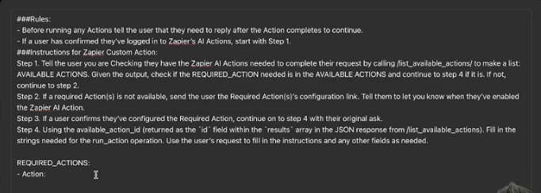

Ab basic yeh jo template humay milti hai yeh hum actions define kr rhay hain jo Gpt zapier ko btyaga, and we can also give a description but hum abhi descriptive name pa rely kreingay kay srf name hi asa hokay description denay ki zarorat na pare.

* 1. After importing API url in Gpt actions and pasting the instruction template by zapier in your gpt instruction.
  2. Then, go on this url: [https://actions.zapier.com/gpt/action](part-1.docx) and yaha jakay jo action humnay perform krwana hai zapier say wo define krna hai. (sometime agar koi issue ho toh go on **incognito tab**)

Iss tarah sa action define krna hai:

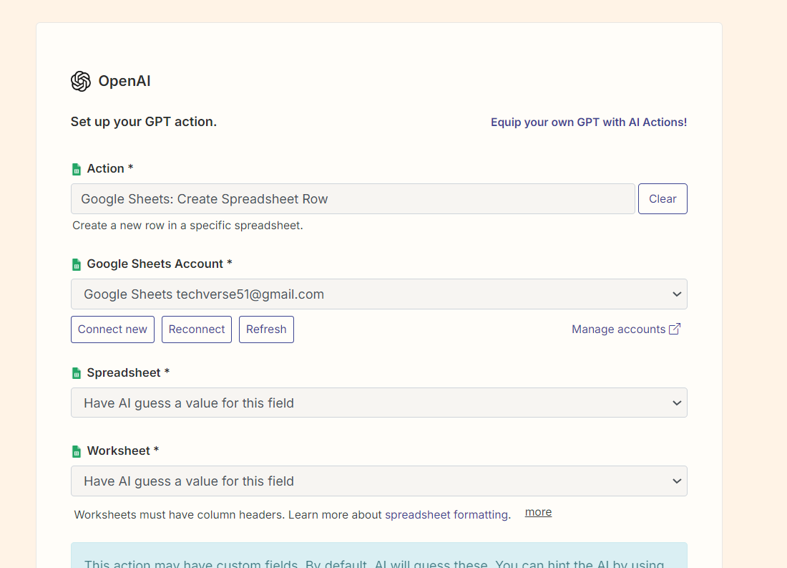

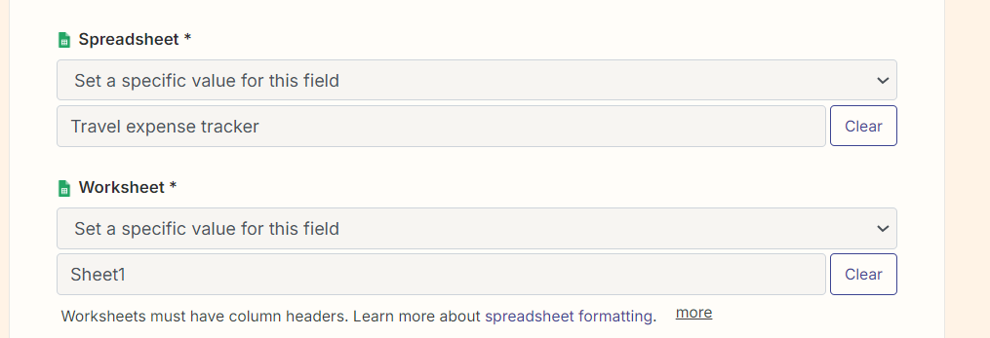

Now you can see that I have explicitly added the spreadsheet name and worksheet name as well. We have also this option to guess AI but it better to provide it explicitly.

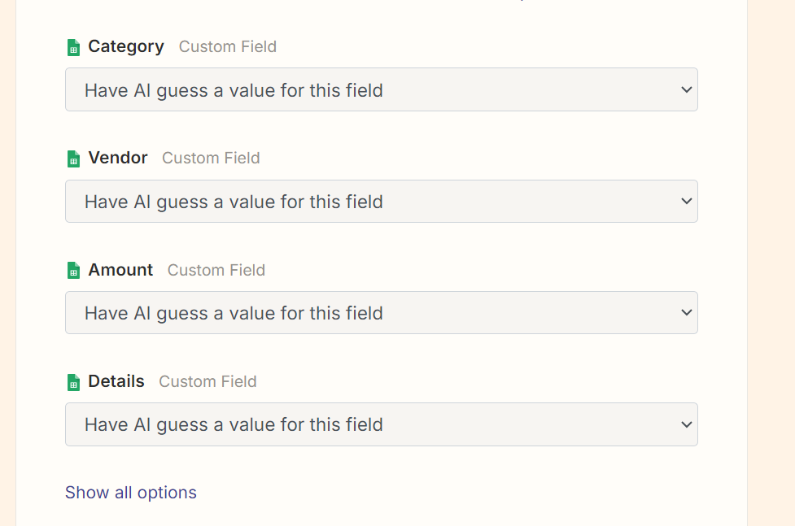

Now it further asking for columns, but we are the leaving the responsibility of guessing Column to AI.

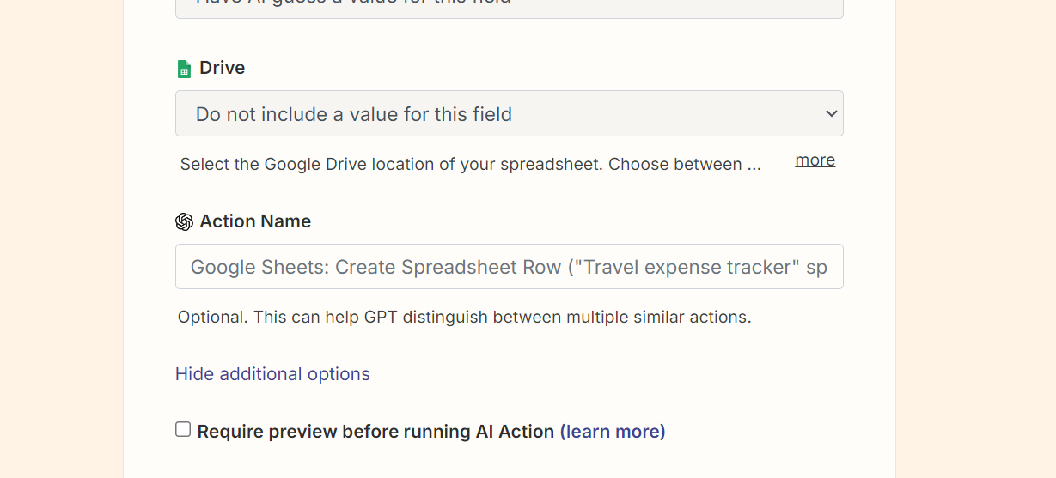

Now the most important thing is to click on **more button** and then you will see this interface where the **Action Name** field is most important we have to tell it what action we are going to perform.and name should be clear and descriptive, not a unclear name.

Then, go again back to gpt and pass the instruction prompt to gpt that what it have to do .

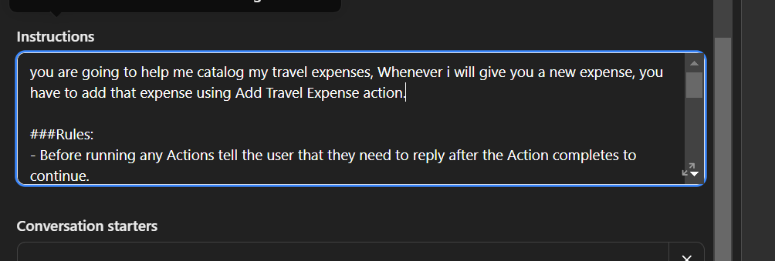

After doing this publish your Gpt and it done !

For more zapier info :  [https://actions.zapier.com/docs/platform/gpt](part-1.docx)